**Project Overview**

This project is inspired by all of the 2D side-scrolling retro style games I’ve played growing up. I’m a huge fan of the Metroidvania style gameplay, so I wanted to attempt to make a project based on the same sort of concepts. This actually started as a Zelda II clone, but more or less changed into its own idea.   
  
The player can:

**Jump**

**Attack in combination**

**Roll**

**Block**

**Controls:**Space: Jump  
WASD/Arrow keys: MovementLeft mouse button: Attack  
Right mouse button: Block  
Shift: Roll

**Enemies**

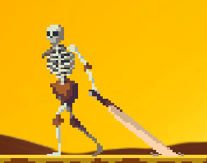

These enemies that are pretty basic skeletons. They have low HP and die in one to two hits. They swing their big sword they’re dragging along on the ground and if the player is within a certain distance, the player will receive damage if not blocking.

**Super Enemies**

This is a super enemy that wields a spear. These guys are tough. Each one you meet will have different HP and defense values, so every encounter will be of varying difficulty. They hit hard, so make sure to watch for the attacks and block at the right timing!

**The Boss**

He will destroy you. No joke. 75% damage per hit. Watch his attacks and block, or you will lose. He has 6 different attacks that are chosen at random.

**Hearts**

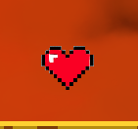

The player’s current health is displayed in the bottom left corner of the screen. These will recover 25% of your HP upon pickup. Use them sparingly!

**Swords**

These are damage bonuses that can be stacked. Try to find all of them for the best damage output! If you don’t, the end of the level might take you a bit to complete. When picked up, these will increase the count in the bottom right corner of the screen, which indicates what level of attack damage the player has reached.

**Known bugs:**   
 -The player will flinch after blocking damage upon releasing the block button.

-Killing an enemy will cause the grounded bool to activate midair, allowing the player to jump upwards indefinitely. The current fix is to put a timer on the jump function so that the player can only jump at a certain interval. Infinite jump is still possible, but the player can no longer climb through the air.

-Upon death, the player’s HP will often not reflect the actual HP values known by the game.

-Blocking can be held indefinitely, thus preventing damage as long as the button is held, even if the animation for blocking is no longer playing. This is currently intentionally left in as a cheat for players who find the game too difficult, however, an idea for fixing this would to put a timer for the maximum amount of time the player can block damage will take place.